
Ugly Christmas Sweater
Sturling Bonspiel
Saturday, November 15th
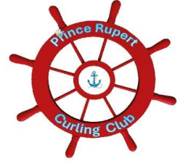

Join us at the Prince Rupert Club for the first bonspiel event of the season:
- One day event
- 2 person teams
- Six end games
- $60 per person (includes dinner)
Enjoy a fun, festive day and night of curling! Everyone Welcome!
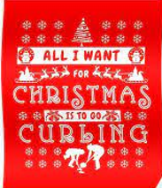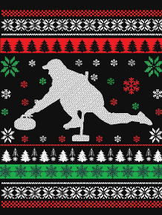
Sign up at the curling club or contact Natasha 250.600.1972
For more information: www.princerupertcurling.ca

